SOFTWARE TESTING
PRACTICAL REPORT
PRACTICAL REVIEW — PR-14

Student Name | Parth Fegade
Enrollment Number | 2504030100083
Programme | BCA — Semester 3
Practical | PR-14 — Selenium Web Automation: Login and Cart Validation
Tools | Python, Selenium WebDriver, Google Chrome, PyCharm, SauceDemo

1. Aim
To automate a shopping workflow on SauceDemo using Selenium WebDriver: open the website, enter valid credentials, validate login, add a product to the cart, open the cart, and verify the resulting URL.

2. Objectives
- Launch Chrome and navigate to SauceDemo.
- Enter username and password and submit the login form.
- Verify that the inventory page opens successfully.
- Add the Sauce Labs Backpack to the cart.
- Open the cart and validate the URL.
- Close the browser after execution.

3. Tools and Environment
Tool / Parameter | Purpose / Details
Python 3.x | Runs the automation script
Selenium WebDriver | Locates elements and automates browser actions
Google Chrome | Browser under test
PyCharm | IDE used to write and run the Python script
SauceDemo | Demo e-commerce website
Target URL | https://www.saucedemo.com/

4. Procedure
1. Create a Python project in PyCharm and create a file named pr14.py.
2. Install Selenium with pip install selenium if it is not already installed.
3. Import WebDriver, locator strategies, explicit waits, and expected conditions.
4. Launch Chrome, maximize the window, and open the SauceDemo login page.
5. Enter standard_user and secret_sauce, then click Login.
6. Wait for the inventory URL and assert that it contains inventory.
7. Click the Sauce Labs Backpack Add to cart button.
8. Click the shopping cart icon, wait for the cart URL, and assert that it contains cart.
9. Close the browser in a finally block to ensure cleanup.

5. Source Code
The code includes explicit waits and validation checks for login, product selection, and cart navigation.
from selenium import webdriver
from selenium.webdriver.common.by import By
from selenium.webdriver.support.ui import WebDriverWait
from selenium.webdriver.support import expected_conditions as EC
driver = webdriver.Chrome()
driver.maximize_window()
wait = WebDriverWait(driver, 10)
try:
# 1. Open SauceDemo
driver.get("https://www.saucedemo.com/")
print("Website opened")
# 2. Enter valid login credentials
wait.until(
EC.visibility_of_element_located((By.ID, "user-name"))
).send_keys("standard_user")
driver.find_element(By.ID, "password").send_keys("secret_sauce")
# 3. Submit login form and validate inventory page
driver.find_element(By.ID, "login-button").click()
wait.until(EC.url_contains("inventory"))
assert "inventory" in driver.current_url
print("Login Validation: PASS")
# 4. Add Sauce Labs Backpack to the cart
wait.until(
EC.element_to_be_clickable(
(By.ID, "add-to-cart-sauce-labs-backpack")
)
).click()
print("Product Selection: PASS")
# 5. Open cart and validate navigation
driver.find_element(By.CLASS_NAME, "shopping_cart_link").click()
wait.until(EC.url_contains("cart"))
assert "cart" in driver.current_url
print("Cart Validation: PASS")
print("Tutorial 14 Completed Successfully")
finally:
driver.quit()

6. Screenshot Evidence
Screenshots document the SauceDemo login page, product inventory, PyCharm source code, and execution output.
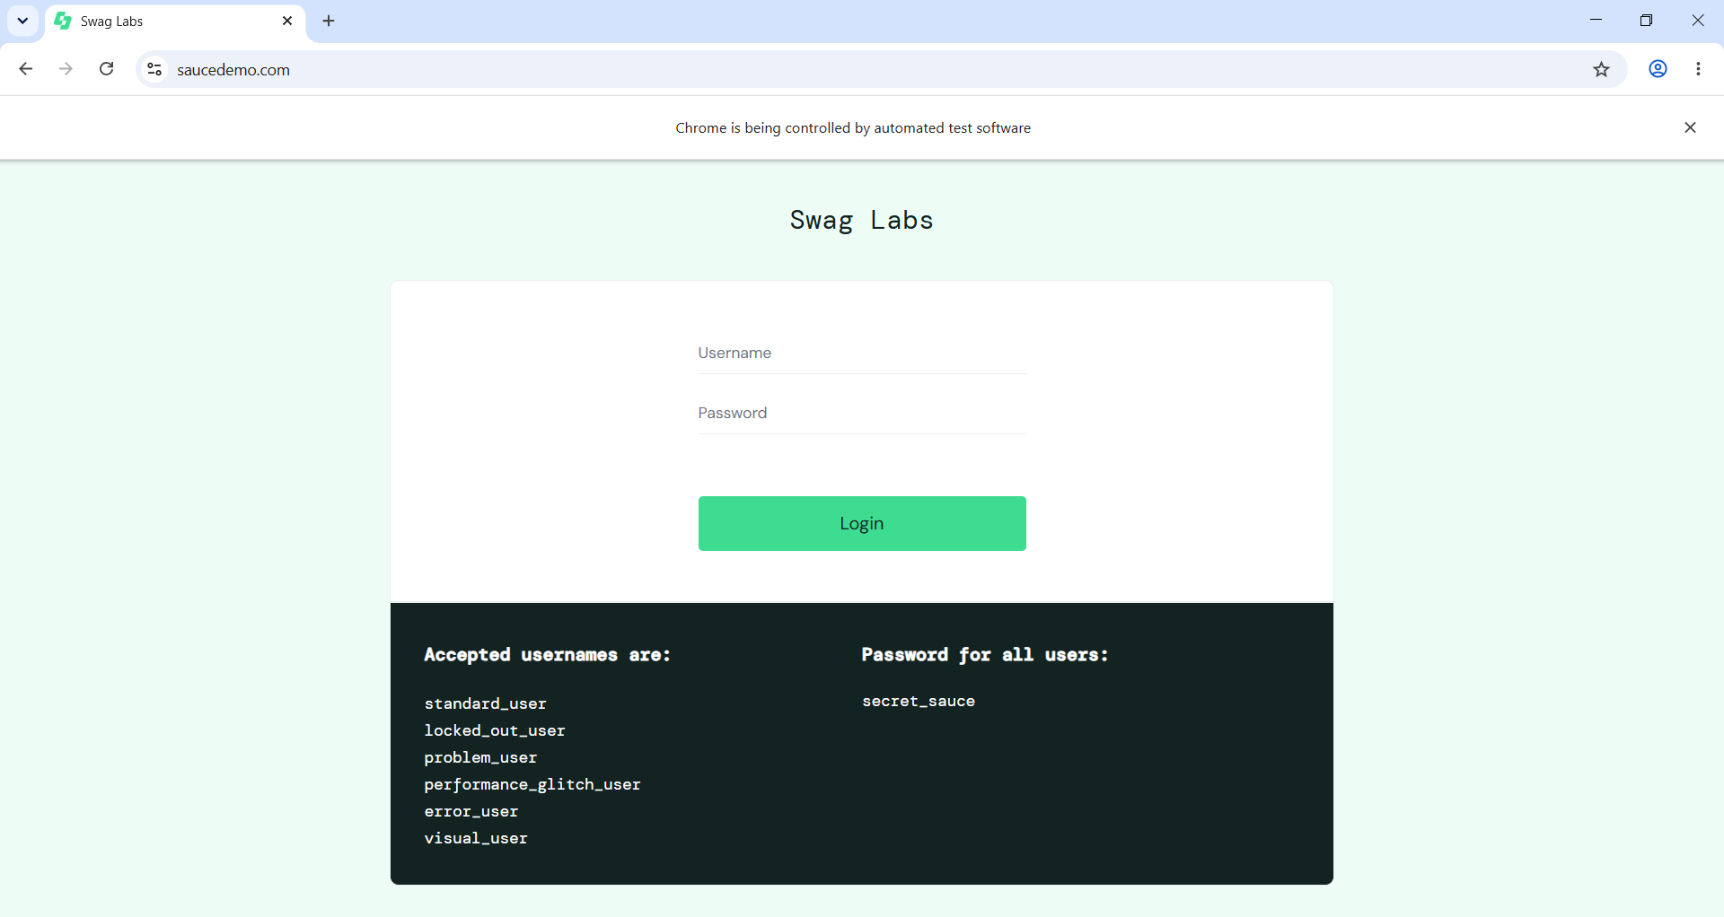
Figure 1. SauceDemo login page with accepted test credentials displayed on the page.
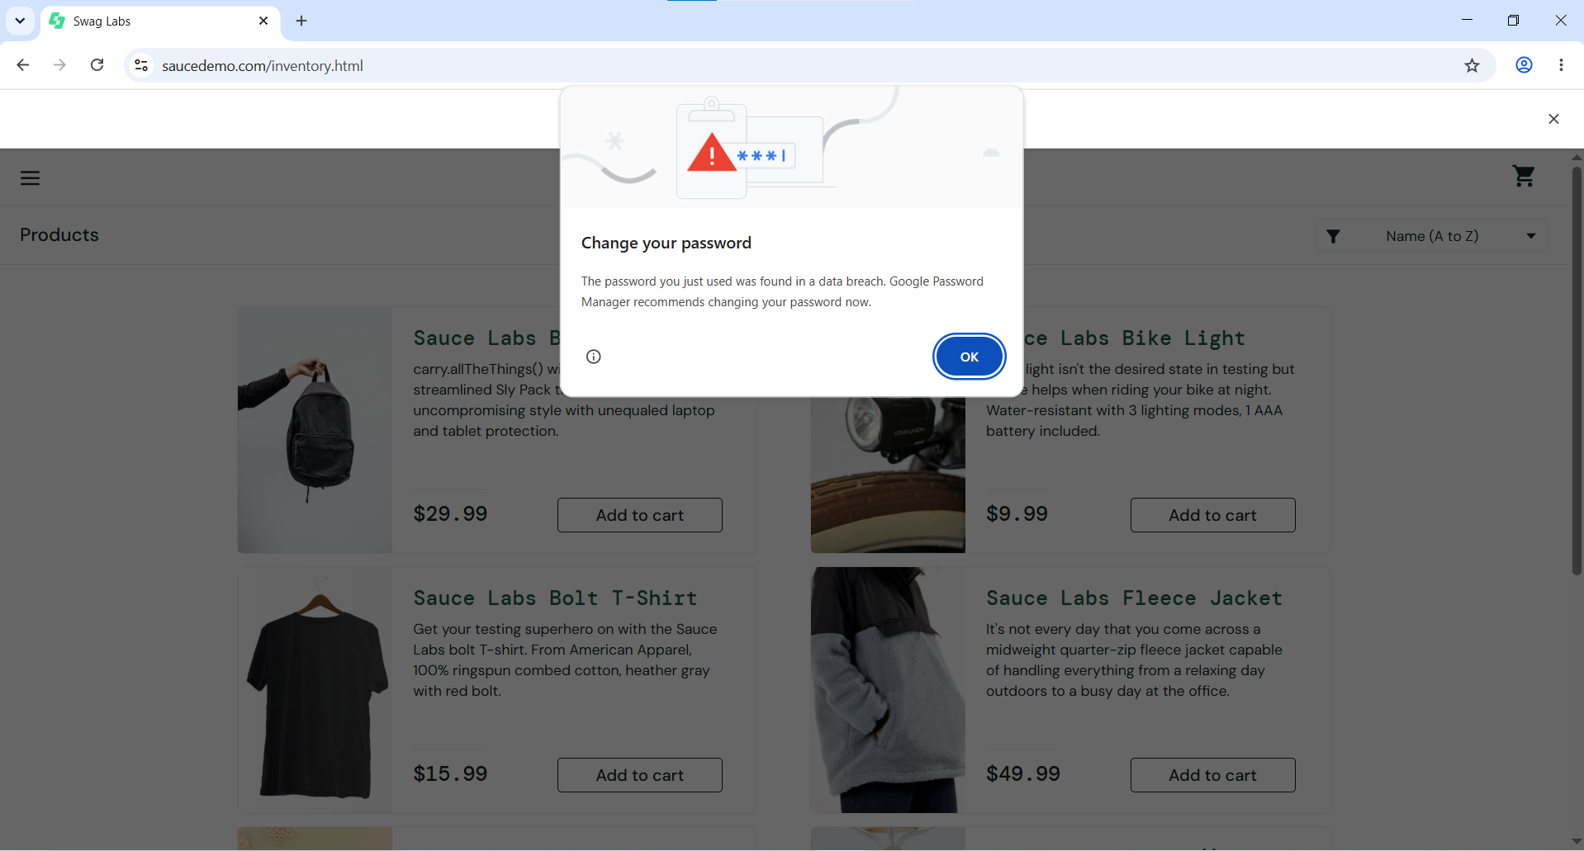
Figure 2. SauceDemo inventory page with product cards visible.
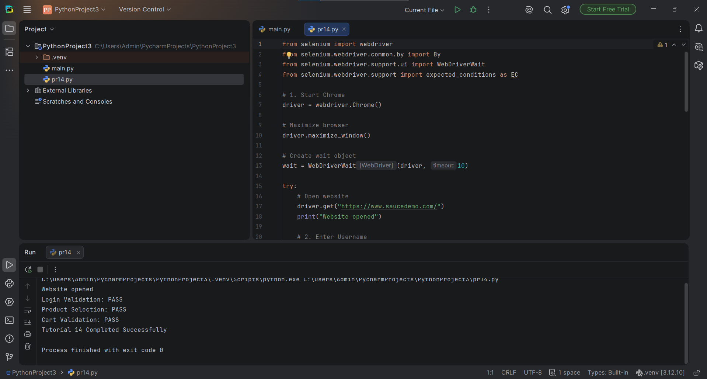
Figure 3. PyCharm source code for the Selenium automation script.
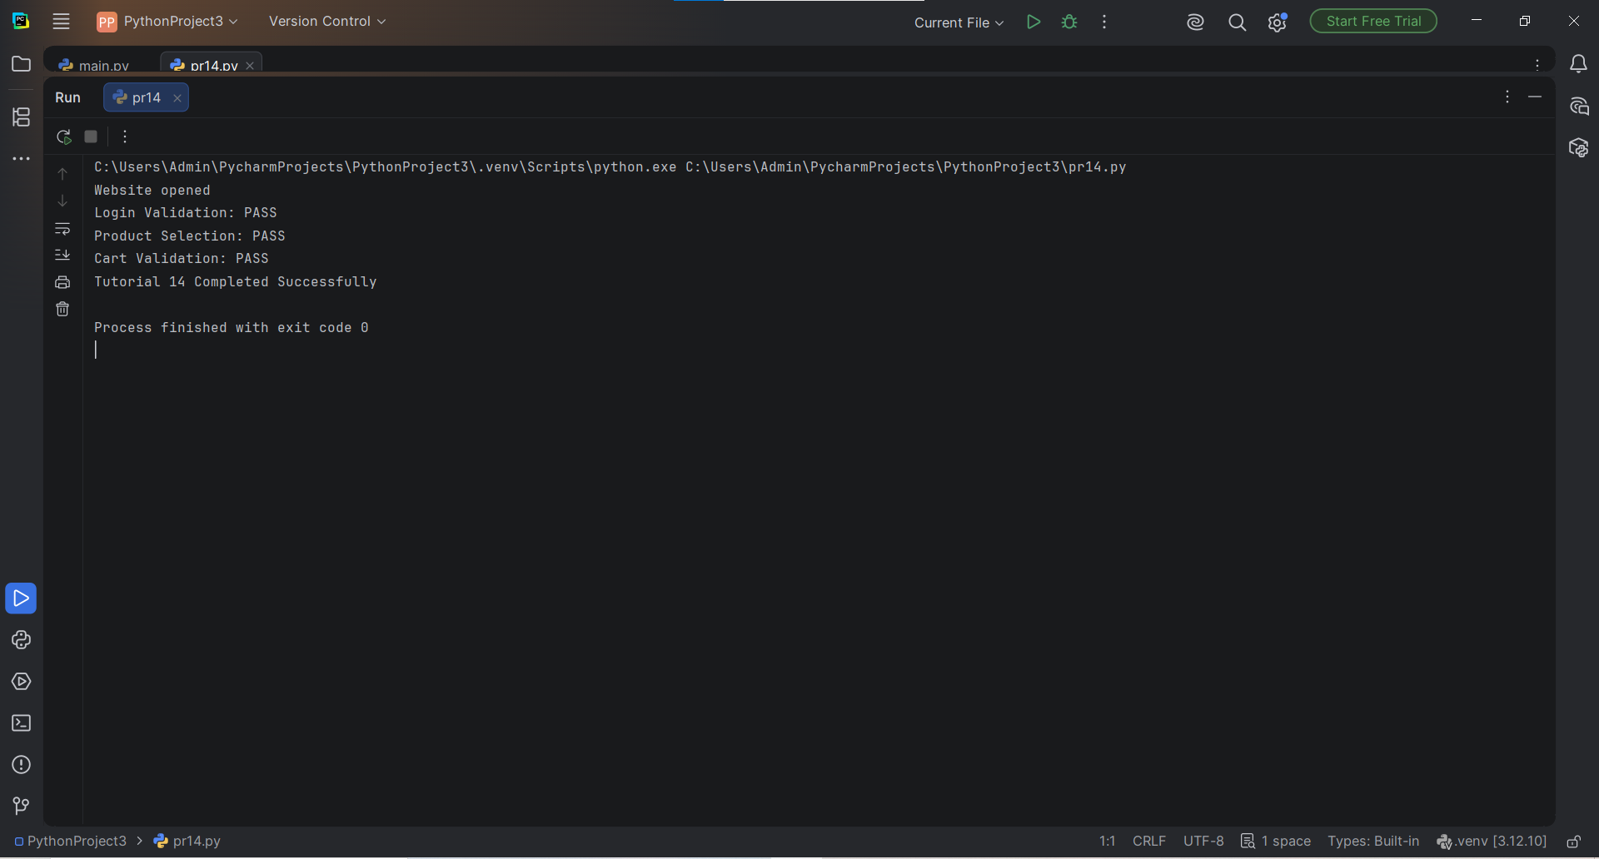
Figure 4. PyCharm console output showing login, product selection, and cart validation as PASS.

7. Test Case Summary
ID | Test | Expected Result | Status / Evidence
TC-01 | Open website | SauceDemo login page loads | Pass — login screenshot
TC-02 | Login | Valid credentials open inventory | Pass — inventory screenshot and console evidence
TC-03 | Add product | Backpack is added to cart | Pass — console reports Product Selection: PASS
TC-04 | Open cart | Cart page opens | Pass — console reports cart validation
TC-05 | Validate URL | URL contains cart | Pass — assertion included in script

8. Observations
- Selenium opened the SauceDemo website in Chrome.
- The supplied console screenshot reports Login Validation, Product Selection, and Cart Validation as PASS.
- The browser screenshot shows the product inventory page; the source code includes cart navigation and URL assertions.

9. Result
The Selenium automation workflow was executed for SauceDemo login, product selection, and cart navigation. The supplied console output reports the main validation steps as PASS and the process exits successfully.

10. Conclusion
This practical demonstrates how Selenium WebDriver can automate browser navigation, handle login forms, interact with web elements, and validate application state using explicit waits and assertions.

